INTERNSHIP REPORT
ON
FINANCIAL ACCOUNTING IN TALLY ERP.9
BY
LALITA

UNIVERSITY ROLL NO. 2025193907

DEPARTMENT OF COMMERCE

GOVERNMENT COLLEGE AHARWALA (BILASPUR)
(KURUKSHTRA UNIVERSITY, KURUKSHTRA)
YEAR OF SUBMISSION - 2026

ACKNOWLEDGMENT
I would like to express my deepest gratitude to all those who have guided, supported and encouraged me throughout the course of my internship.
First and foremost, I would like to extend my sincere thanks to Dr. Sarvjeet Kaur, Principal Government College, Aharwala (Bilaspur), for her inspiring leadership, encouragement and providing me this opportunity, resources and a platform to enhance my knowledge and skill,
I would like to extend my sincere thanks to Mr. Rahul Saini, Teacher of Authorized Training Partner of: M/s Global Infosys, and C Language Internship Mentor, for his constant guidance, motivation and valuable insights. I am also grateful to Ms. Anukriti Mam, Internship Supervisor, and Ms. Chanchal Rani, Internship Incharge, for their continuous support and encouragement My heartful thanks Ms. Aarti Arora, Internship Coordinator, for her assistance and cooperation during the internship period.
Finally, extend a special thanks to my father, Mr. Darshan Kumar for always being my strongest support system and providing me with the necessary resources, care, and encouragement to achieve my goals.

INTERNSHIP CERTIFICATE




TABLE OF CONTENTS:
- Certificate
- Acknowledgments
- About the organization
- Objectives of Internship
- Details of Work done
- Learning Experiences
- Learning Outcomes
- Conclusion / Summery
- Attachments

INTRODUCTION
Financial accounting is the formal process of recording, summarizing, and reporting business money transactions. It creates standard reports like balance sheets and income statements. These reports show a company's financial health to people outside the business, such as investors, banks, and tax offices
Tally ERP.9 is an accounting software record day by day transaction in business.


ABOUT THE ORGANIZATION
Global Infosys, Jagdhri is a computer education and IT training institute dedicated to providing technical education and practical knowledge to students. The organization focuses on developing programming, software development, and computer application skills through classroom instruction and hands-on laboratory practice. It aims to bridge the gap between academic learning and industry requirements by offering practical training and internship opportunities.
The institute provides training in various programming languages and software technologies, enabling students to build strong technical foundations. During the internship, students gain practical experience by writing programs, solving programming problems, and developing small software applications under the guidance of experienced instructors.
Global Infosys provides training in various computer-related subjects, such as:
- Financial accounting in Tally ERP.9
- Tally prime
- MS Office, MS excel, MS Powerpoint
- Internet Applications
- Database Management
- Software Development Basics
Global Infosys, Jagdhri provided practical training about Tally ERP.9 The training covered fundamental concepts such as basics of Accounting and tally Setup, Voucher Entry and Inventory Management, Advanced Accounting and Banking.

OBJECTIVES OF INTERNSHIP

- To gain practical knowledge of Accounting and Tally.
- To understand calculate the net result of business operations over a specific period.
- To replace human memory by systematically recording every financial transaction.
- To state the exact value of assets and liabilities using a Balance Sheet.
- To track stock movements, multiple godowns, and manufacturing processes seamlessly.

DETAIL OF WORK
WEEK 1: BASICS AND COMPANY SETUP
COMPANY:
In Tally.ERP9, a Company is the basic operational unit and the central database where you store all financial data, transactions, and inventory records for a specific business entity. It acts as an independent electronic file or folder for a single organization.
Day 1-2: Learn how to install Tally.ERP9 and create a new company, alter company, shut company and select company
STEPS HOW TO CREATE COMPANY:
- Go To > Gateway of tally
- Press Alt + F3 (Company Info) > Create Company > FILL The Requried Information.
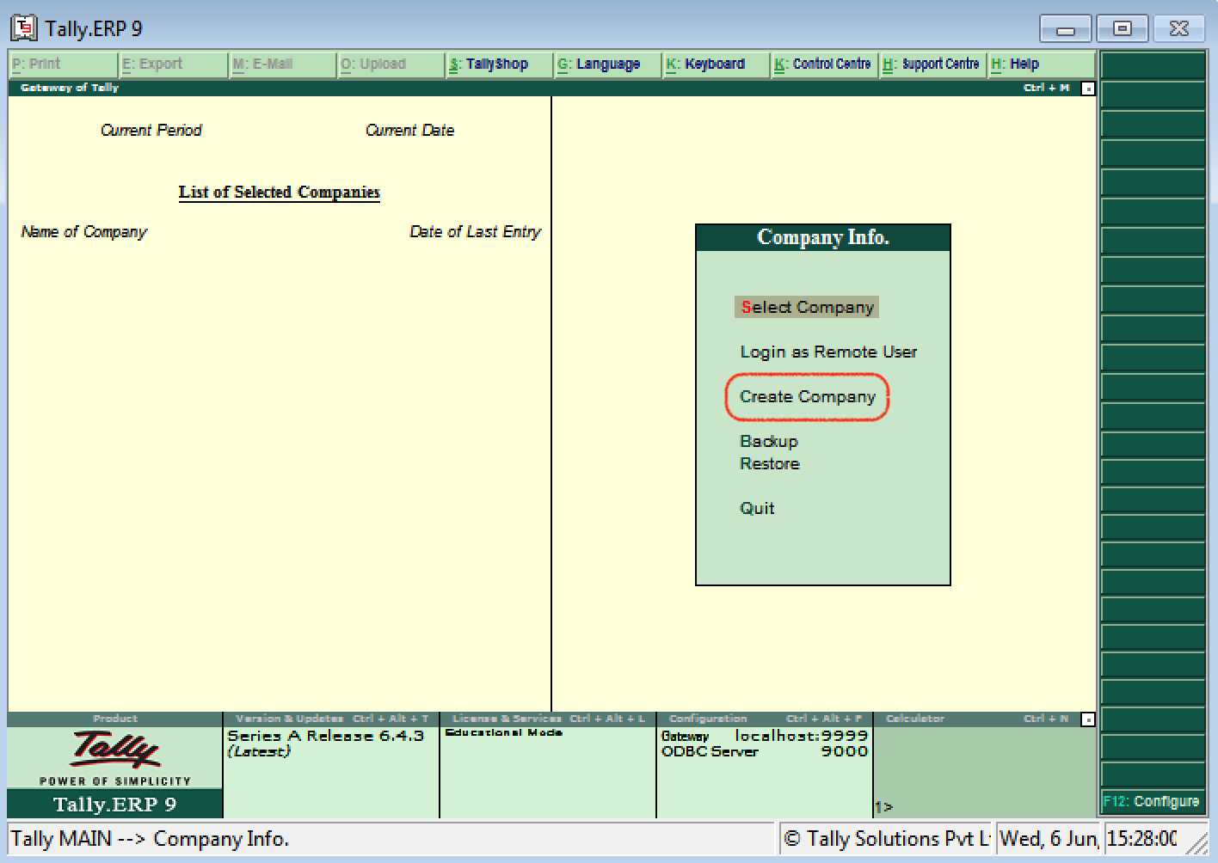
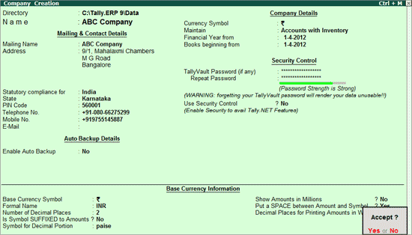

STEPS HOW TO ALTER COMPANY:
- Go To > Gateway of tally
- Press Alt + F3 (Company Info) > Alter Company > Changes the information.
- Press Ctrl + A.
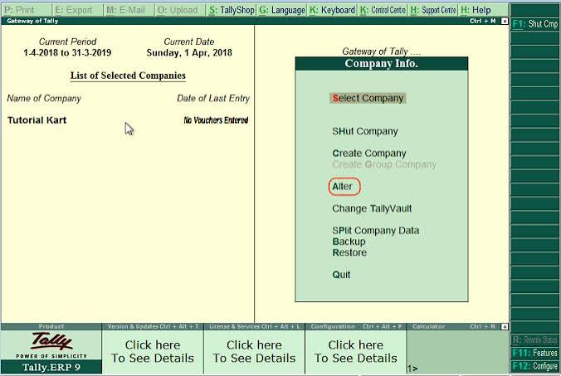

Day 3-4: UNDERSTAND ACCOUNTING TERMS LIKE DEBIT, CREDIT, ASSETS, AND LIABILITIES.
Assets: In Tally, an Asset is anything of value that belongs to your business.
LIABILITIES: In Tally ERP 9, liabilities represent the financial obligations or debts that a business owes to outsiders, lenders, or suppliers.
DEBIT: In Tally ERP 9, a Debit (Dr) is an accounting entry that records an increase in assets and expenses, or a decrease in liabilities, equity, and revenue.
CREDIT: In Tally ERP 9, a Credit (Cr) is an accounting entry that records an increase in liabilities, equity, and revenue, or a decrease in assets and expenses.

DAY 5-7: CREATE SINGLE AND MULTIPLE LEDGER ACCOUNTs.
LEDGER: In Tally.ERP9, a Ledger is an individual account head used to store and identify transactions of a similar nature. It is the actual account where money values are recorded, and you cannot enter a transaction in Tally without using at least two ledgers (Debit and Credit).
STEPS HOW TO CREATE LEDGER:
- Go to Gateway of Tally > Accounts Info. > Ledgers > Create (under Single Ledger).
- Type the unique Name of the ledger.
- Select the parent category from the List of Groups (e.g., Sundry Creditors, Sales Accounts).
- Fill in address and opening balance details if needed, then press Accept or Y to save.
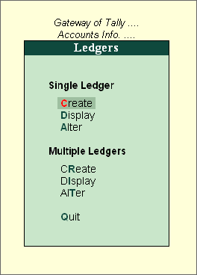
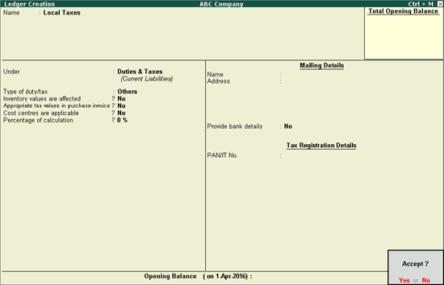STEPS HOW TO DISPLAY AND LEDGER:
- Go to Gateway of Tally > Accounts Info. > Ledgers > Display (under Single or Multiple Ledgers).
- Choose the ledger name from the list to view its details.
- Note: You can view details in display mode, but you cannot make any text or number changes.
STEPS HOW TO ALTER LEDGER:
- Go to Gateway of Tally > Accounts Info. > Ledgers > Alter (under Single or Multiple Ledgers).
- Select the ledger you want to change from the list.
- Make the necessary updates to the name, group, or address, and press Accept to save.
- Press Alt + D
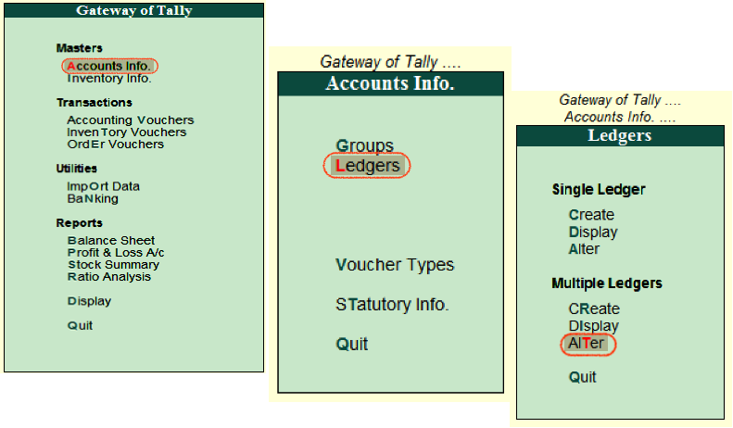
Week 2: Recording Financial Transactions
- feeding stock in a godown: Feeding stock in godown means entering or recording the physical movement, storage, and location of inventory items into a specific warehouse or storage room.
Day 1-2: Practice FEEDING STOCK IN GODWON AND STOCK TRANSFER
- Open Tally and go to Gateway of Tally.
- Select Inventory Info.
- Click on Stock Items and choose Create.
- Type the Name of the item.
- Select the Unit (like Pcs or Kg). Press Alt + C
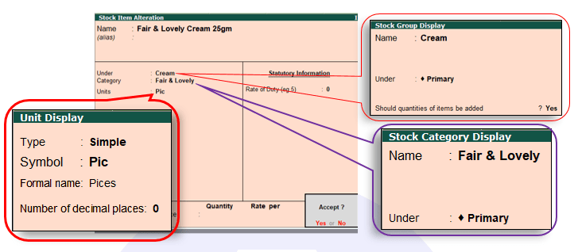
Stock transfer in tally:
In Tally.ERP9, a stock transfer is the internal movement of inventory from one warehouse, location, or godown to another.
Open the Stock Journal Voucher:
- Go to Gateway of Tally > Inventory Vouchers. Press Alt + F7 (or click Stock Journal on the right button bar).
- The screen will split into two halves: Source (Consumption) on the left and Destination (Production) on the right. 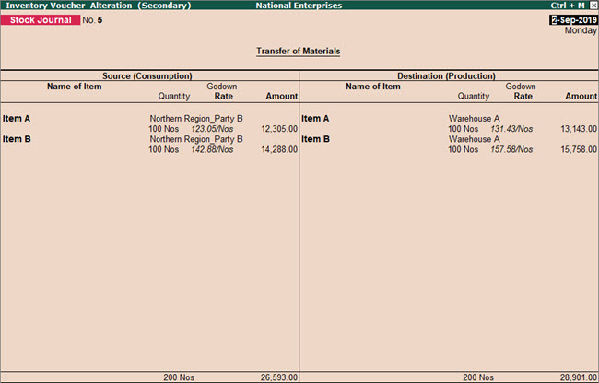
Day 3-4: record purchase transactions with debit note invoice mode.
PURCHASE INVOICE MODE:
- Press F9 for Purchase voucher.
- Enter the Supplier Invoice No. and Date.
- Select the Party's A/c Name.
- Choose the appropriate Purchase Ledger.
- Select the Item Name, Quantity, and Rate.
- Save the screen with Ctrl + A.

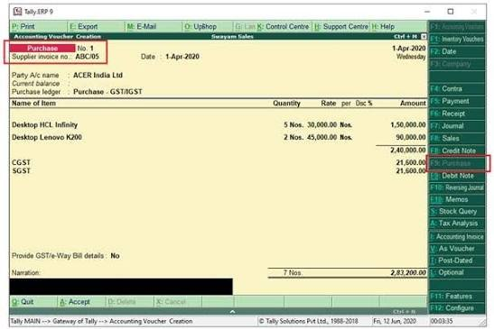
DEBIT NOTE INVOICE MODE:
- Go to Gateway of Tally > Select Accounting Vouchers.
- Press Ctrl + F9 (or click Debit Note). Enter the Original Invoice No. and Date of purchase.
- Select the supplier in Party’s A/c Name.
- Choose your Purchase Return Ledger.
- Select the Item Name, Quantity, and Rate. Press Ctrl + A.

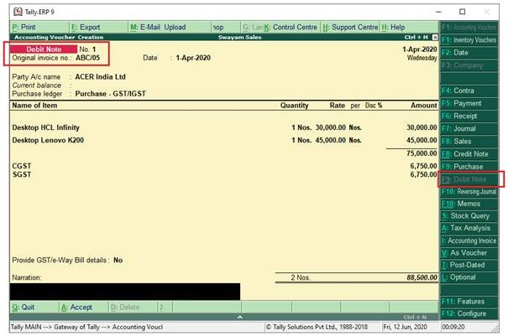
Day 5-7: sale transactions with credit note
SALES INVOICE MODE:
- Press F9 for Purchase voucher.
- Enter the Supplier Invoice No. and Date.
- Select the Party's A/c Name.
- Choose the appropriate Purchase Ledger.
- Select the Item Name, Quantity, and Rate.
- Save the screen with Ctrl + A.

- 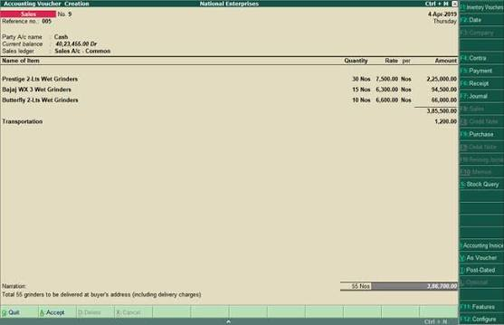

CREDIT NOTE INVOICE MODE:
- Sales Go to Gateway of Tally > Select Accounting Vouchers.
- Press Ctrl + F8 (or click Credit Note). Enter the Original Invoice No.
- Select the customer in Party’s A/c Name.
- Choose your Sales Return Ledger.
- Select the Item Name, Quantity, and Rate.
- Press Ctrl + A to save.
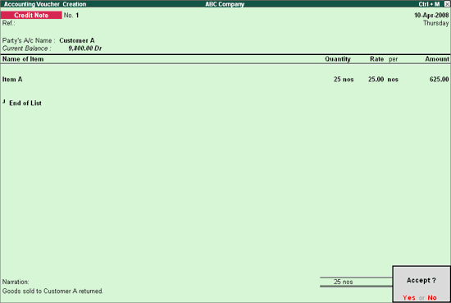

Week 3: RECORDING TRANSACTION IN Order Processing:
DAY 1-2: Purchase order processing
Purchase order: is the systematic workflow an organization follows to purchase goods or services from a supplier. It tracks the entire transaction from the initial request to the final delivery and payment. 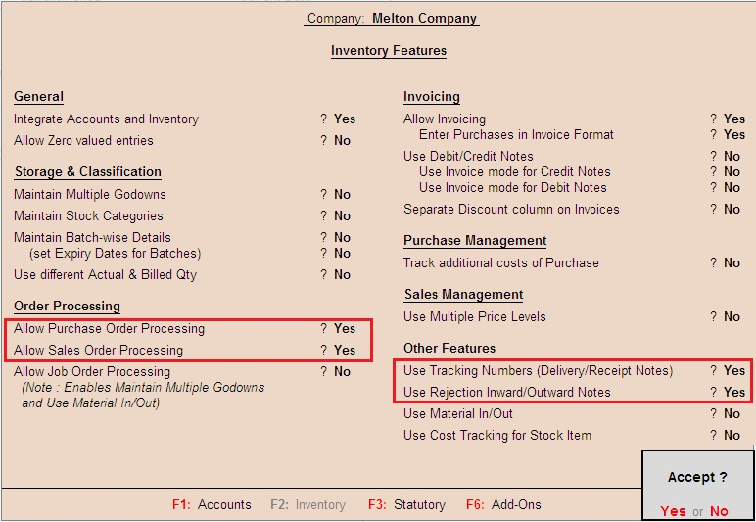

STEPS HOW TO RECORDED PURCHASE ORDER TRANSACTION:
- Go to gateway of tally > press F11, F2 enable the features.
- Press alt+f4 purchase order fill the order no. > godown name > party’s name > and stock item.
- Press att+f9 received all the goods > check the material.
- Press f9 for bill with rates > fill the rate of material
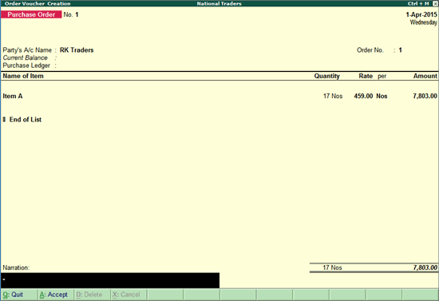

DAY 3-4: SALES ORDER PROCESSING: in Tally.ERP9 is a document that records a formal commitment or contract from a customer to buy goods or services from your business.
STEPS HOW TO RECORDED PURCHASE ORDER TRANSACTION:
- Go to gateway of tally > press F11, F2 enable the features.
- Press alt+f5 purchase order fill the order no. > godown name > party’s name > and stock item.
- Press att+f8 received all the goods > check the material.
- Press f8 for bill with rates > fill the rate of material

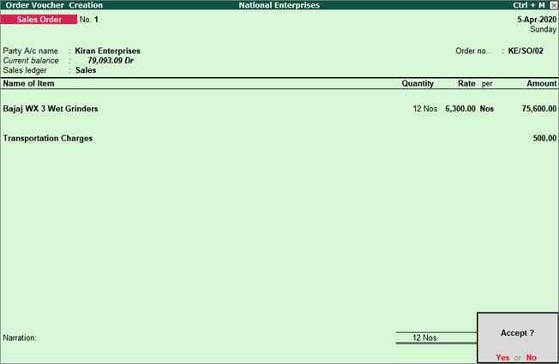

DAY 5-6: RECORDING REJECTION IN AND REJECTION OUT TRANSACTION
In Tally.ERP9, Rejection Out and Rejection In are inventory vouchers used to record the return of goods before a final financial invoice is generated.
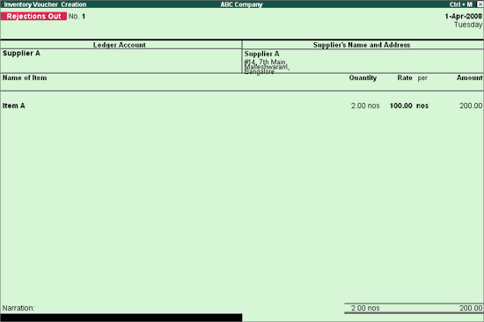

STEPS FOR RECORDING REJECTION OUT AND REJECTION IN TRANSACTION IN TALLY ERP 9:
- Go to gateway of tally > press F11, F2 enable the features.
- Press alt+f4 purchase order fill the order no. > godown name > party’s name > and stock item.
- Press att+f9 received all the goods > check the material.
- Press alt + f6 for rejection out and rejection ctrl + f6 for rejection in fill the return material. Press ctrl + A.
- Press f9 for bill with rates > fill the rate of material

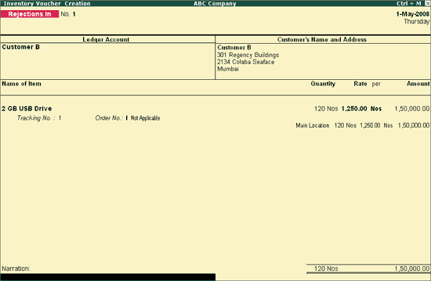
Week 4: MANGE TRANSACTION COST CENTRE AND STANDARD COST:
DAY 1-2: COST CENTRE AND COST CATEGORY
Cost Centre: In Tally.ERP9 is an allocation unit or a specific segment of an organisation to which income or expenses can be directly assigned
- Open your company in Tally.ERP9.
- Go to Gateway of Tally > Press F11: Features.
- Select Accounting Features > Find Maintain Cost Centre. Set Yes.
- If you need multiple cost-centre categories, also set Maintain more than one payroll or cost category to Yes.
- Press Ctrl + A to save the settings.

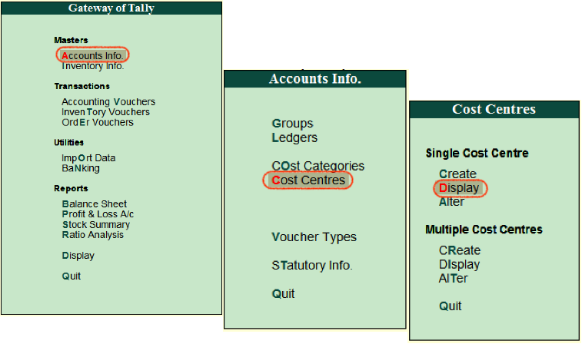

To Create a Cost Centre:
After enabling the feature:
Gateway of Tally → Accounts Info. → Cost Centre → Create
Then:
- Enter the Cost Centre Name (e.g., Marketing, Production, Delhi Branch).
- Select Primary or an existing parent cost c
DAY 3-4 STANDARD COST
- Go To Gateway OF Tally
- Press F12 > Enable Standard Cost Option
- Go To Inventory Info > Create Stock Item > Set Standard Option > Fill the Rate of Item Selling Cost And Standard Cost
- Press Yes.

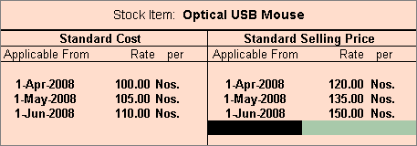
DAY 5-6 PRACTICE SESSION of standard cost
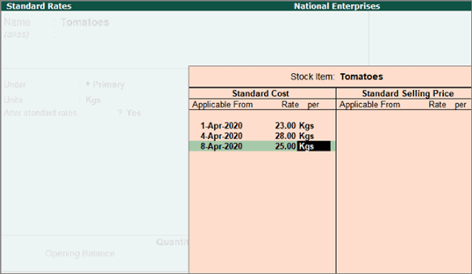

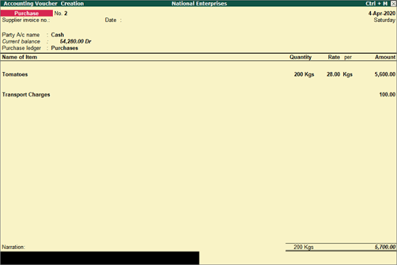

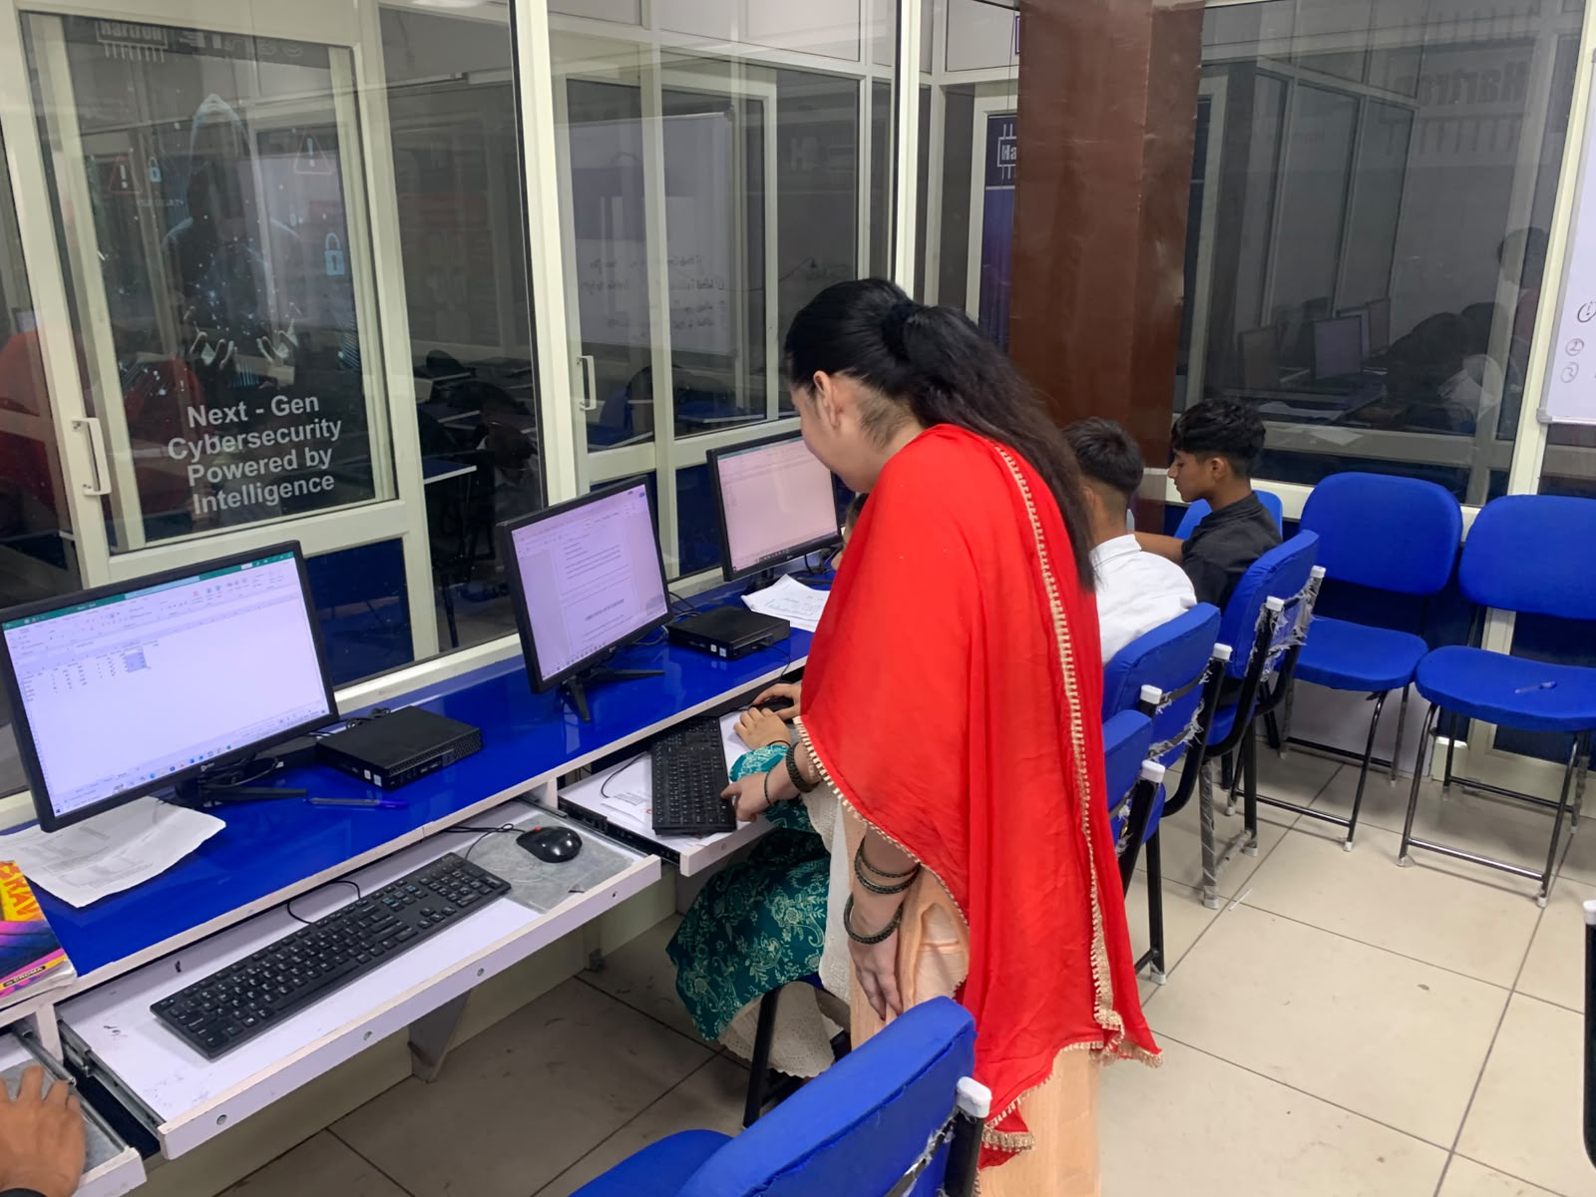

ATTENDANCE SHEET
DATE | TIME IN | TIME OUT | STATUS
10/6/2026 | 12:00 | 1:30 | Present
11/6/2026 | 12:00 | 1:30 | Present
12/6/2026 | 12:00 | 1:30 | Present
13/6/2026 | 12:00 | 1:30 | Present
15/6/2026 | 12:00 | 1:30 | Present
16/6/2026 | 12:00 | 1:30 | Present
17/6/2026 | 12:00 | 1:30 | Present
18/6/2026 | 12:00 | 1:30 | Present
19/6/2026 | 12:00 | 1:30 | Present
20/6/2026 | 12:00 | 1:30 | Present
22/6/2026 | 12:00 | 1:30 | Present
23/6/2026 | 12:00 | 1:30 | Present
24/6/2026 | 12:00 | 1:30 | Present
25/6/2026 | 12:00 | 1:30 | Present
26/6/2026 | 12:00 | 1:30 | Present
27/6/2026 | 12:00 | 1:30 | Present
29/6/2026 | 12:00 | 1:30 | Present
30/6/2026 | 12:00 | 1:30 | Present
ATTENDANCE SHEET

Date | Time in | Time out | status
1/7/2026 | 12:00 | 1:30 | Present
2/7/2026 | 12:00 | 1:30 | Present
3/7/2026 | 12:00 | 1:30 | Present
4/7/2026 | 12:00 | 1:30 | Present
6/7/2026 | 12:00 | 1:30 | Present
7/7/2026 | 12:00 | 1:30 | Present
8/7/2026 | 12:00 | 1:30 | Present
9/7/2026 | 12:00 | 1:30 | Present
10/7/2026 | 12:00 | 1:30 | Present
11/7/2026 | 12:00 | 1:30 | Present
13/7/2026 | 12:00 | 1:30 | Present
14/7/2026 | 12:00 | 1:30 | Present
15/7/2026 | 12:00 | 1:30 | Present
16/7/2026 | 12:00 | 1:30 | Present
17/7/2026 | 12:00 | 1:30 | Present
18/7/2026 | 12:00 | 1:30 | Present
20/7/2026 | 12:00 | 1:30 | Present
21/7/2026 | 12:00 | 1:30 | Present
ATTENDANCE SHEET
22/7/2026 | 12:00 | 1:30 | Present
23/7/2026 | 12:00 | 1:30 | Present

LEARNING OUTCOMES:
Understand basic accounting concepts: and apply principles of financial accounting using Tally ERP 9.
Create and manage company accounts: including company creation, alteration, and configuration.
Create and maintain ledgers and groups for different accounts such as cash, bank, purchases, sales, expenses, and income.
Record accounting transactions using vouchers such as payment, receipt, contra, journal, purchase, and sales vouchers.
Prepare and maintain financial statements, including the Trading Account, Profit and Loss Account, and Balance Sheet.
Manage cash and bank transactions and maintain accurate records of receipts and payments.
Handle inventory-related accounting by maintaining stock groups, stock items, units of measurement, and inventory records.
Understand and apply taxation features, including GST-related accounting and tax calculations in Tally ERP 9.
Generate and interpret accounting reports such as Trial Balance, Day Book, Ledger, Cash Book, and outstanding reports.

CONCLUSION:

Tally ERP 9 is an effective and user-friendly accounting software that plays an important role in modern financial accounting. It helps businesses and organizations record, classify, and manage financial transactions accurately and efficiently. Features such as ledger creation, voucher entry, inventory management, taxation, bank reconciliation, and preparation of financial statements make accounting processes faster and more systematic.

